# Installation and Configuration Steps

## Installation Steps of Talend Software

1. We are getting the below error as shown in the screenshot below while opening the Talend Software in the system as Java is not installed/configured.

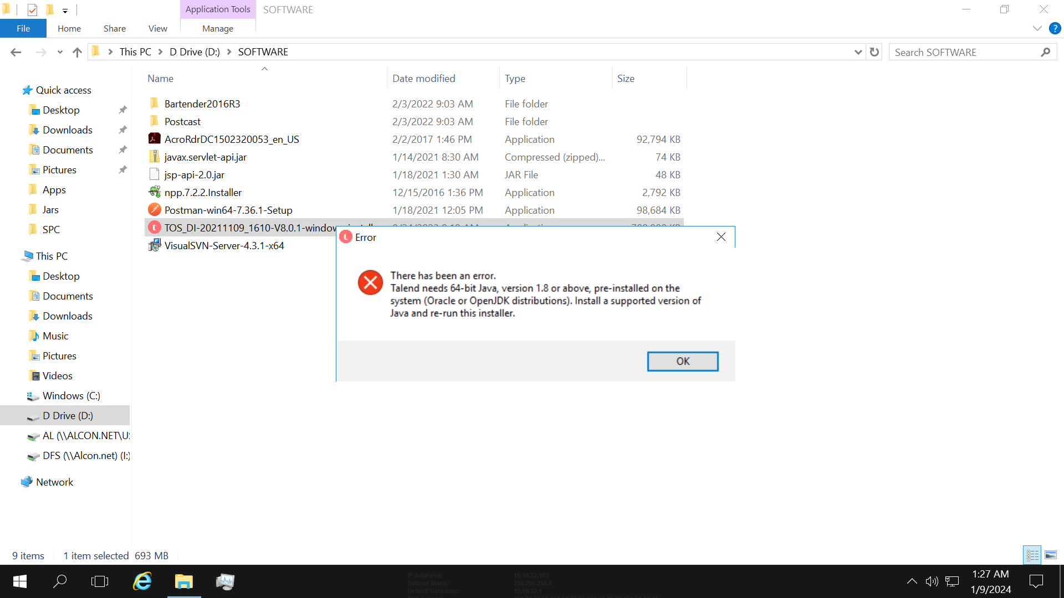

1. To configure the Java in the system, right click on the start button and select the System as shown in the below image.

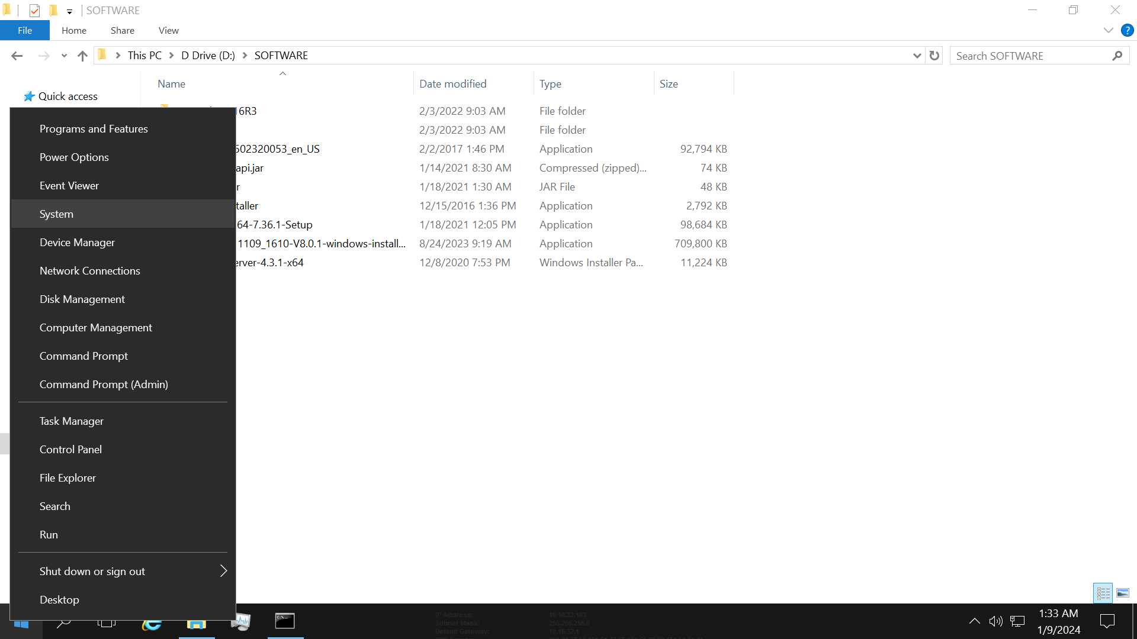

3. Then click on the Advance System Settings from the left-hand list.

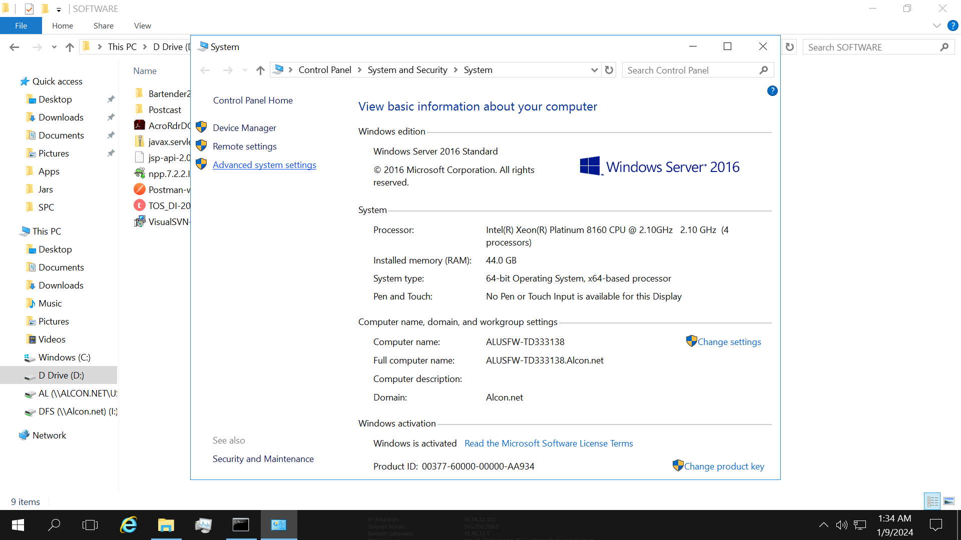

4. Select the Advanced tab from the System Properties popup as shown below. And then click on Environment Variables button to configure the Java path.

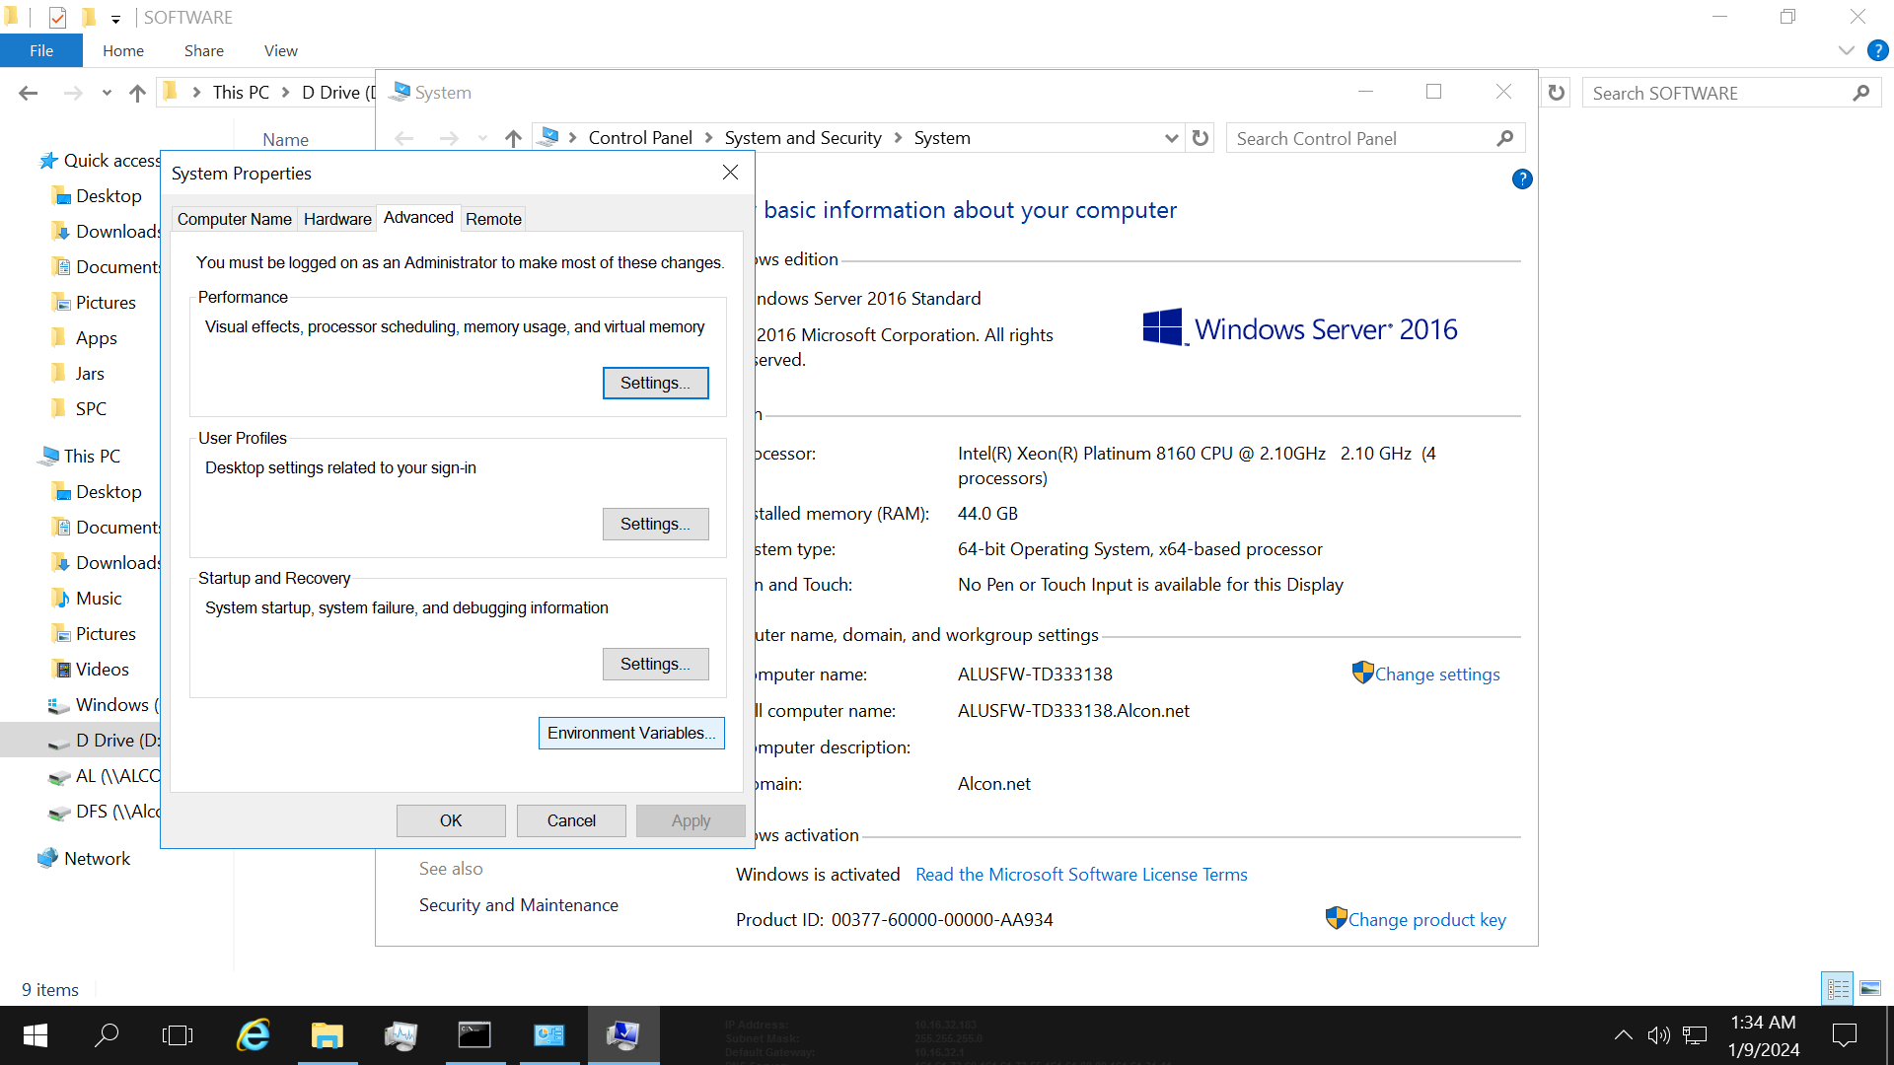

5. Then click on New button to add path in the System variables.

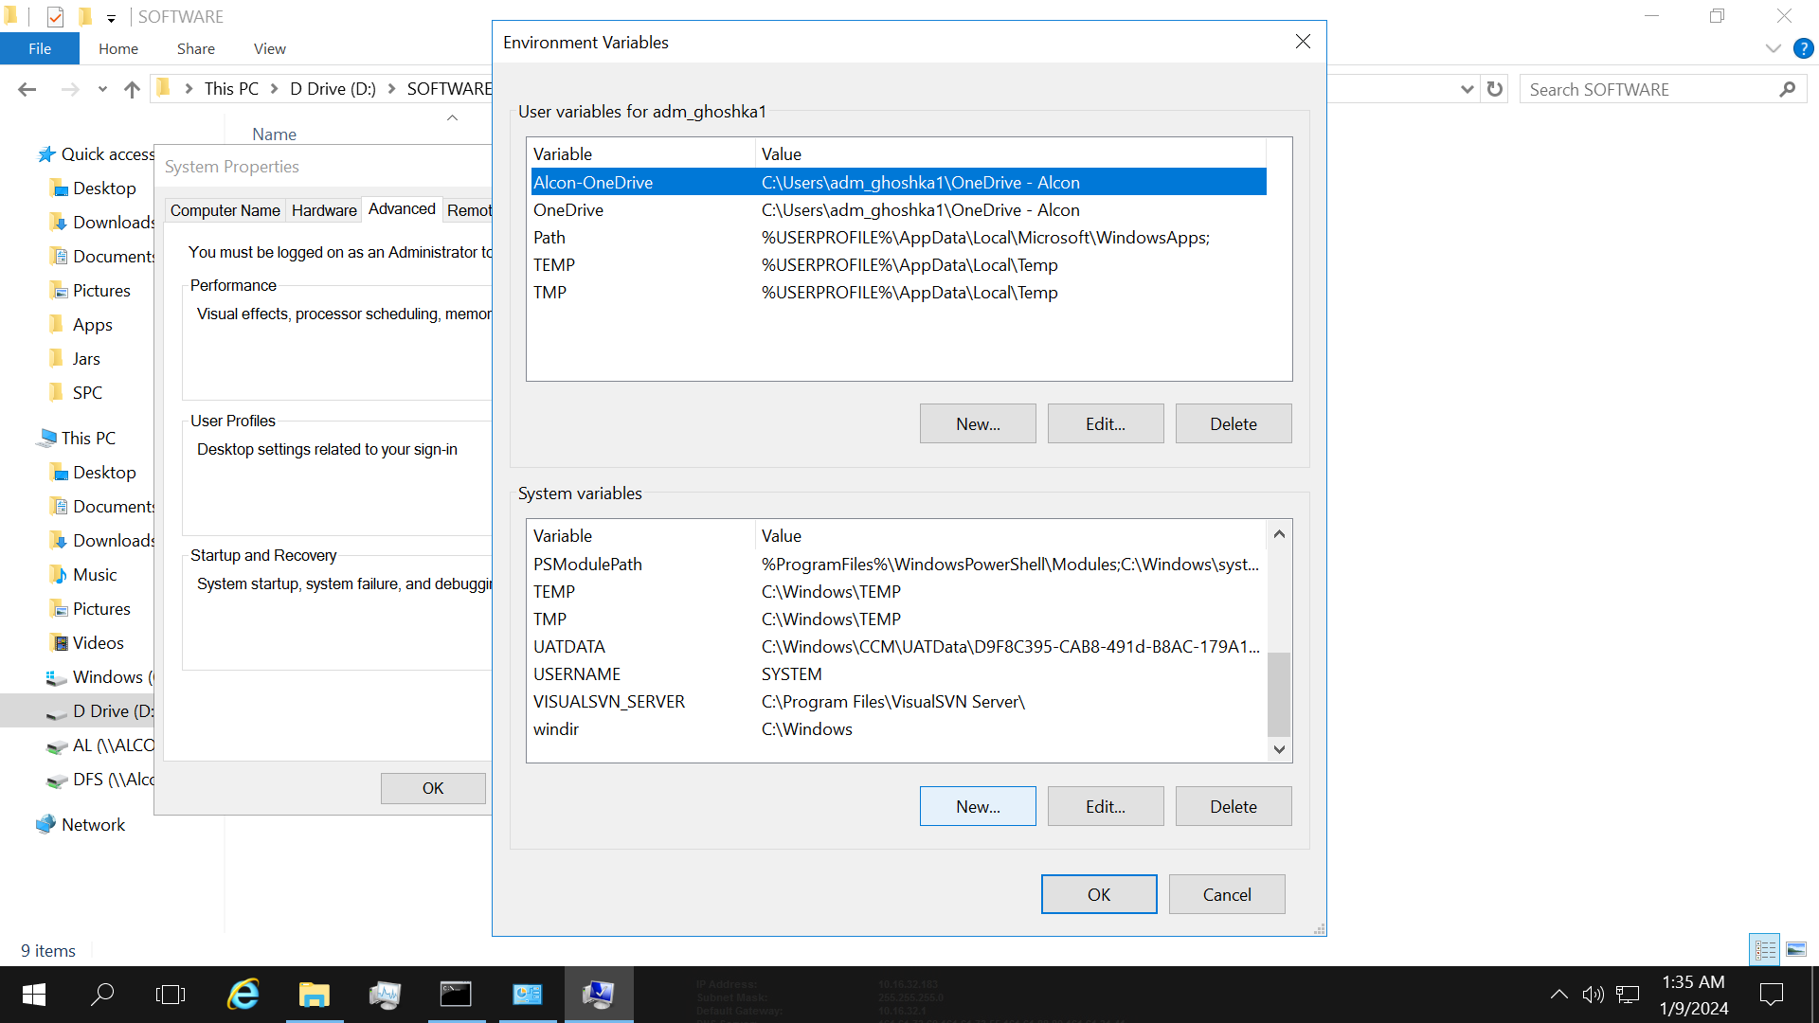

6. Provide the Variable name and Variable value. Variable value can be set using Browse Directory button. Then click on OK button.

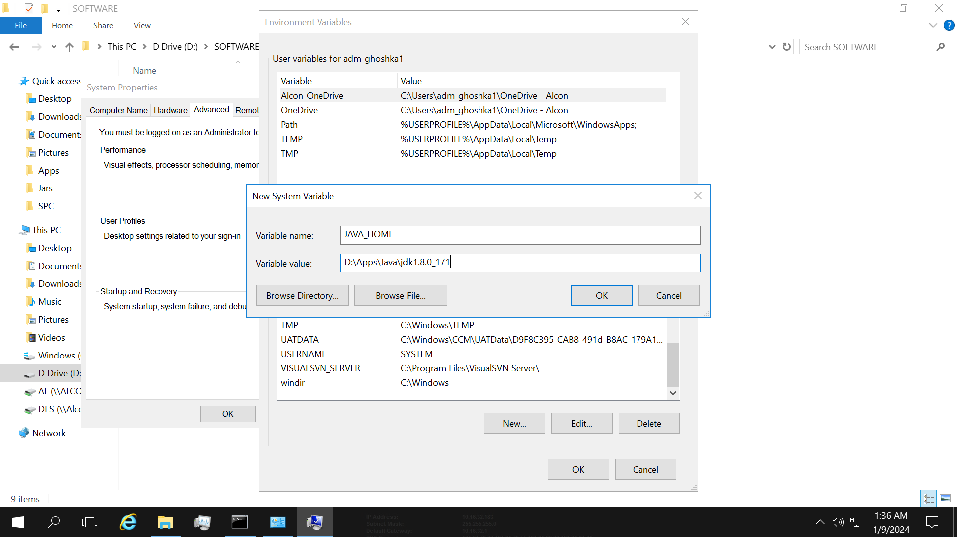

7. We have to select path from System Variable and then click on Edit button.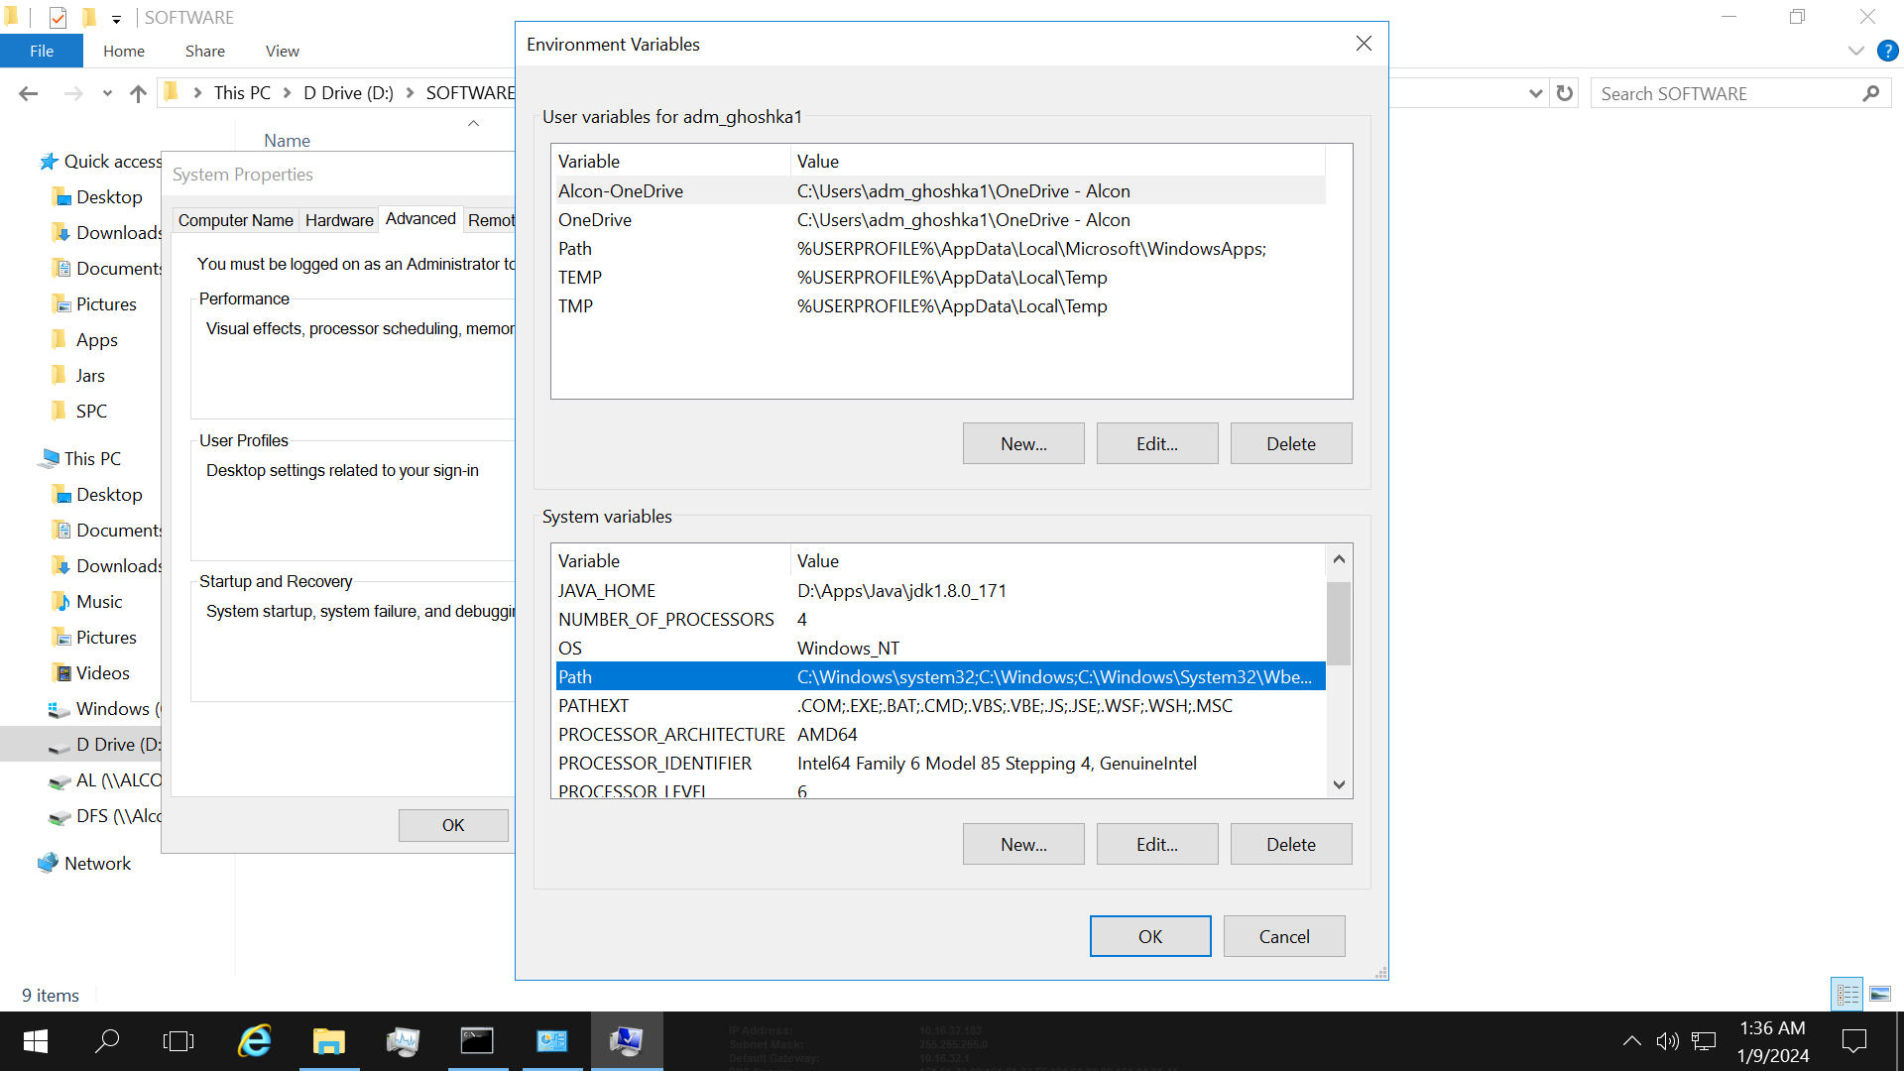

8. Click on New button and add “%Java_Home%\bin” as shown in the below screenshot. Then click on OK button.

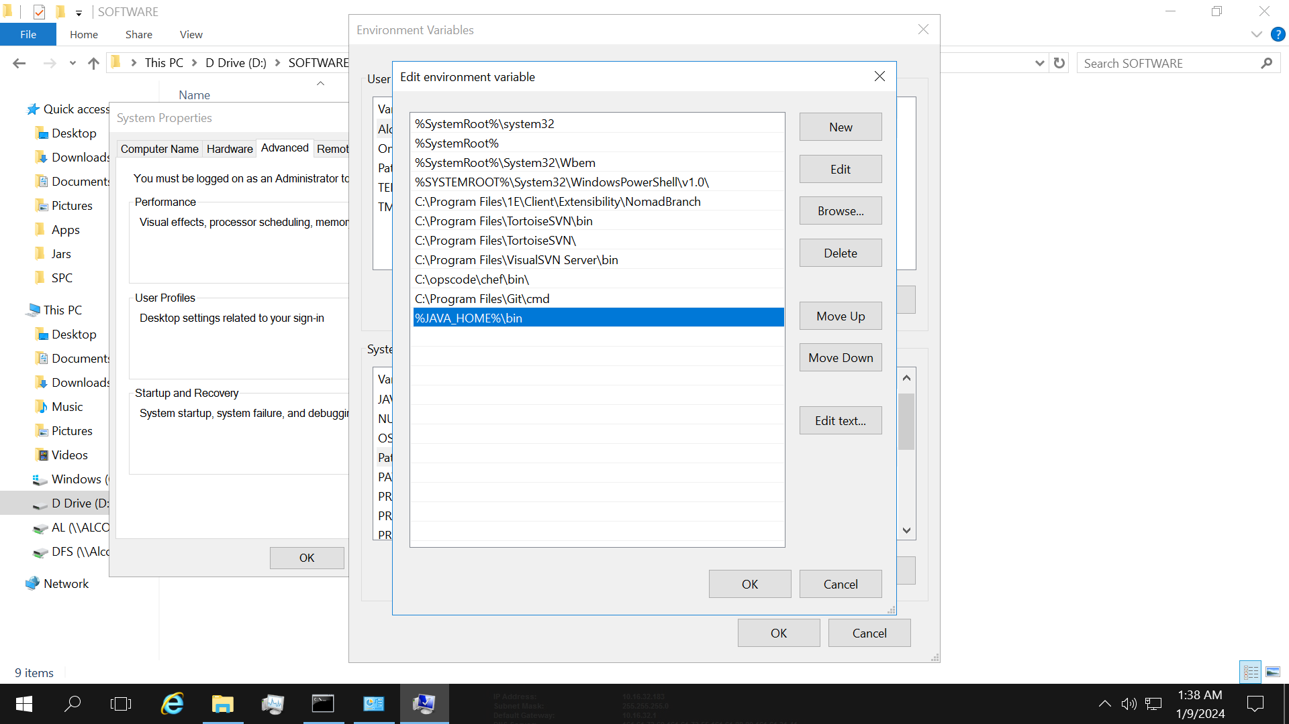

.

9. Again click on OK button.

10. Open CMD then the check the JAVA version by using the command “java -version”. If Java is installed/configured properly in the system you will get the java version after running the command as show below in the image.

11. Now again open the Talend software after configuring the java in the system the below screen will appear. Then click on Next.

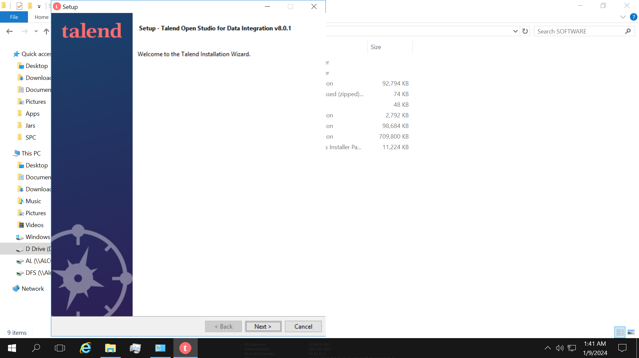

12. Now accept the License by clicking on the “I accept the agreement” radio button. Then click on Next.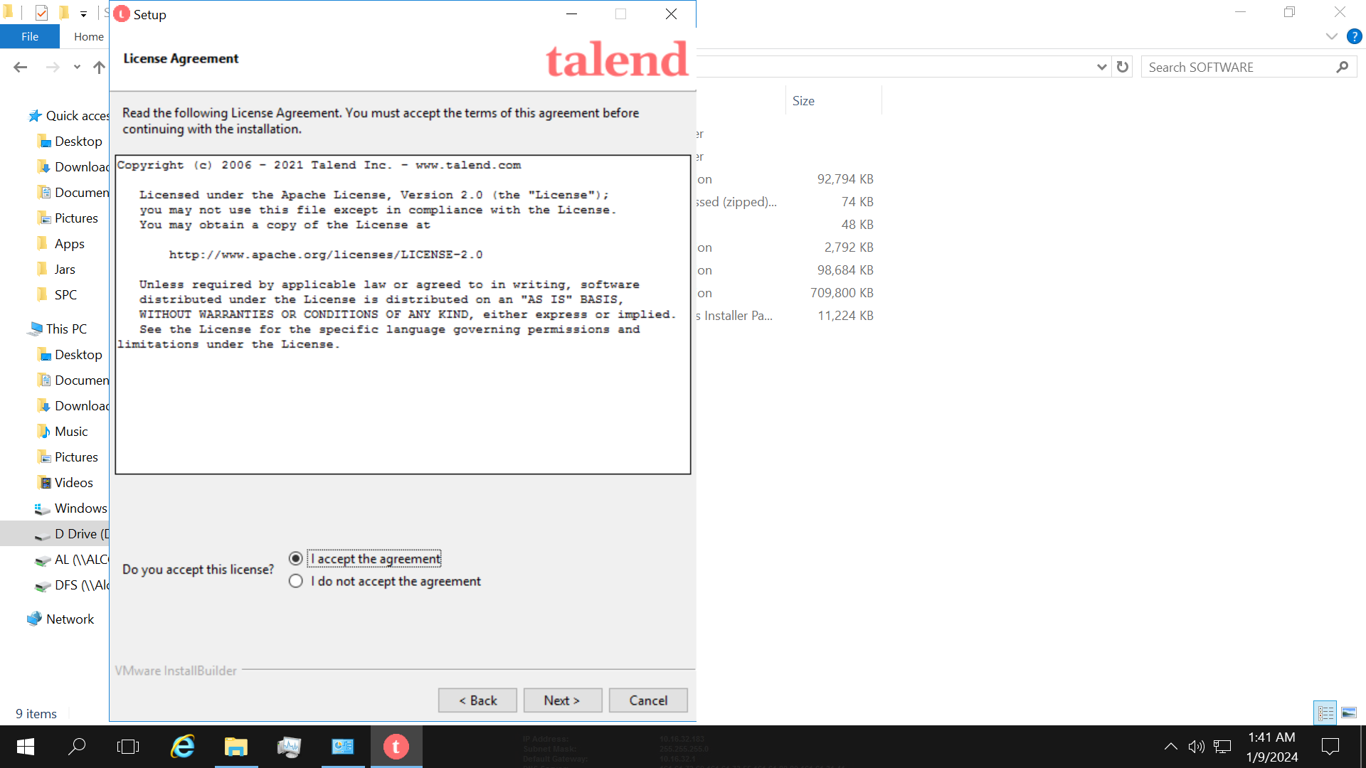

13. Then click on Next button.

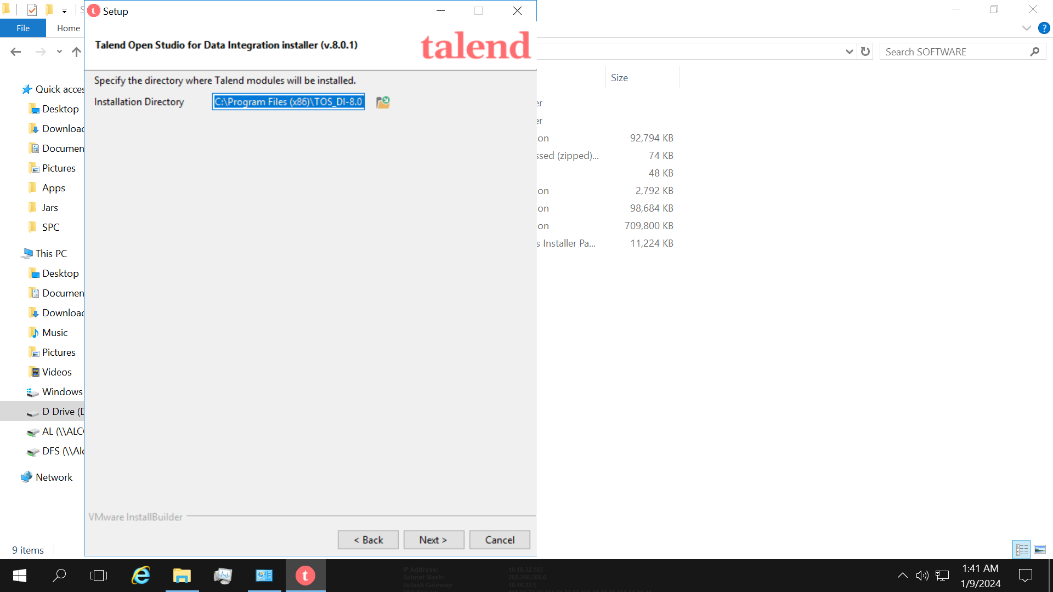

14. Now the setup is ready to install on the local server. And then click Next button.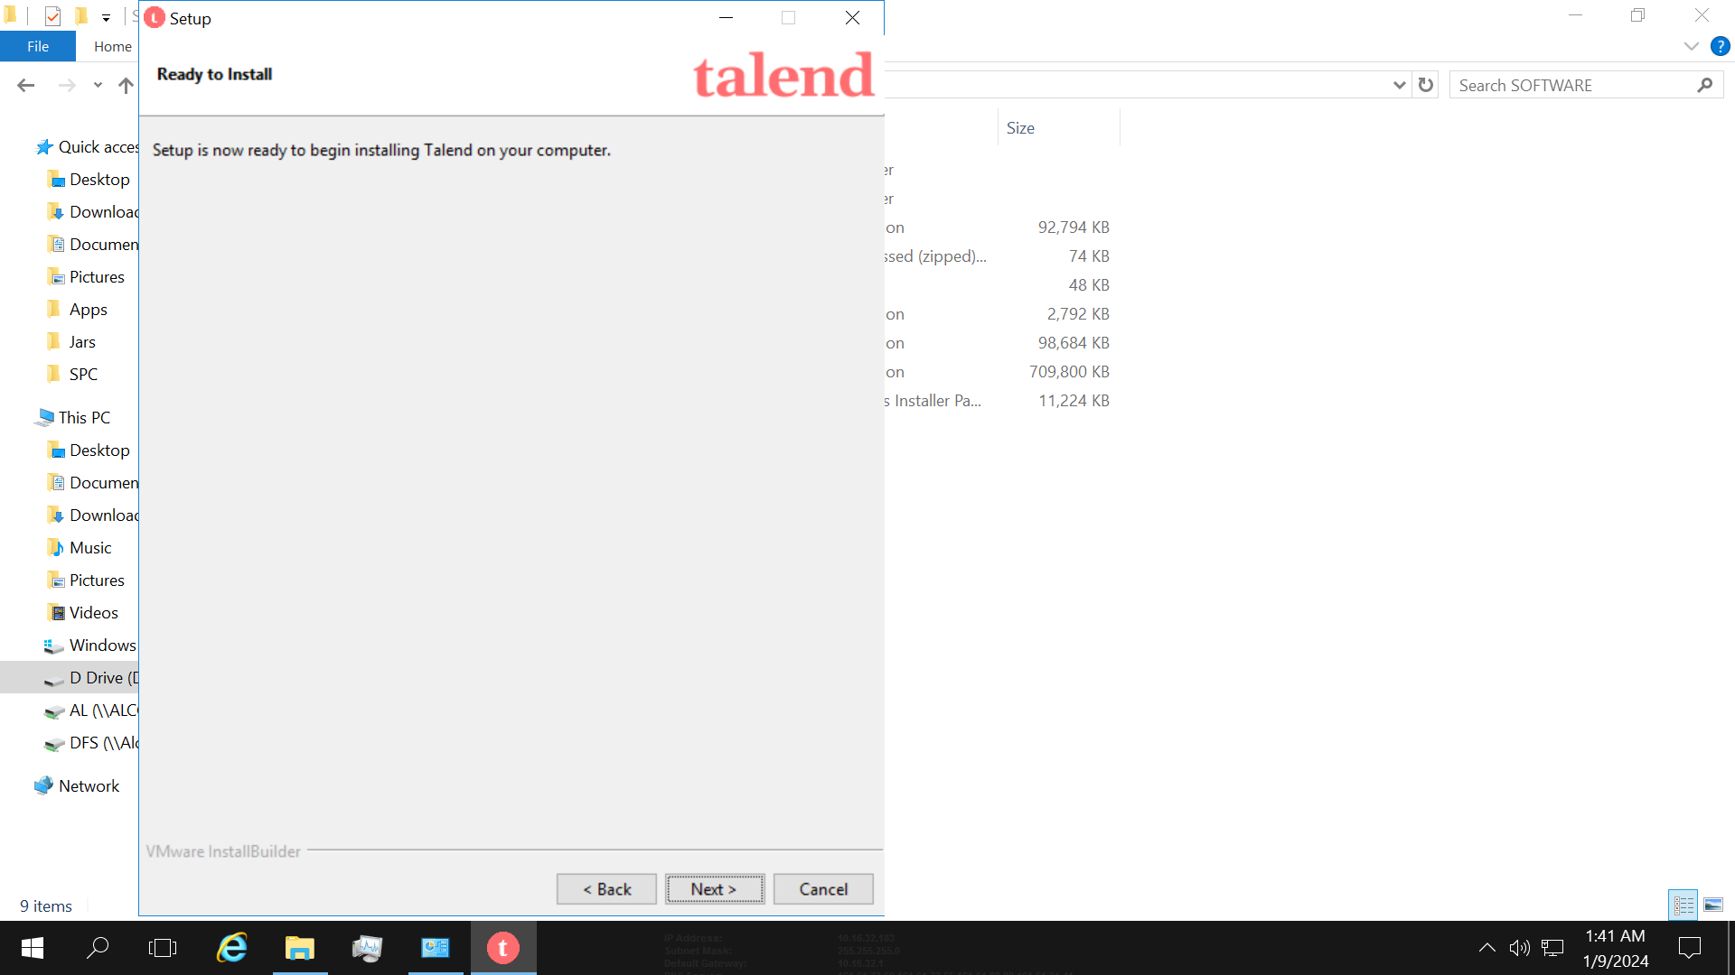

15. Once the installation is done click on Finish button.

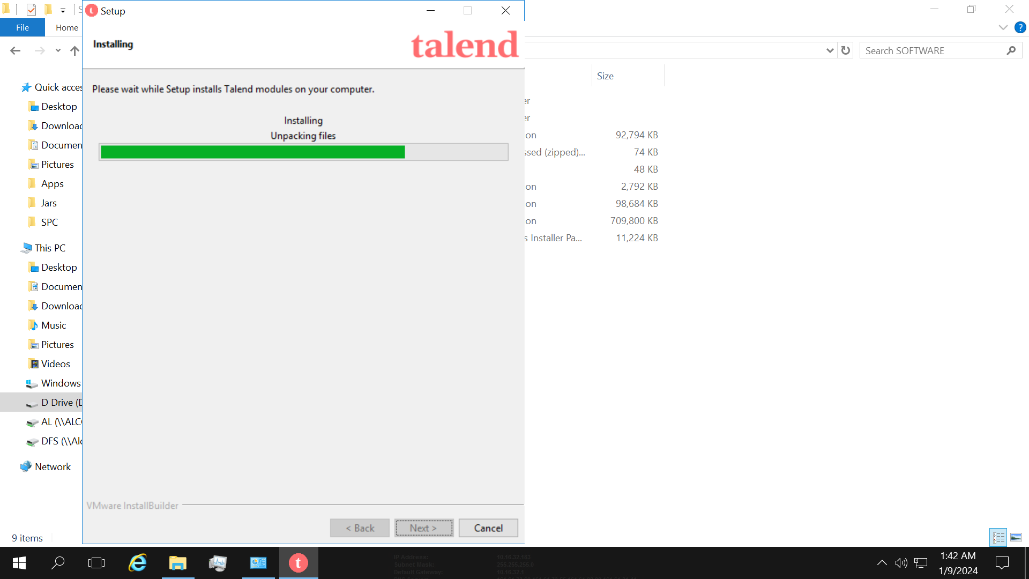

16. After successful installation of Talend software desktop icon will appear on the desktop as shown in the below screenshot.

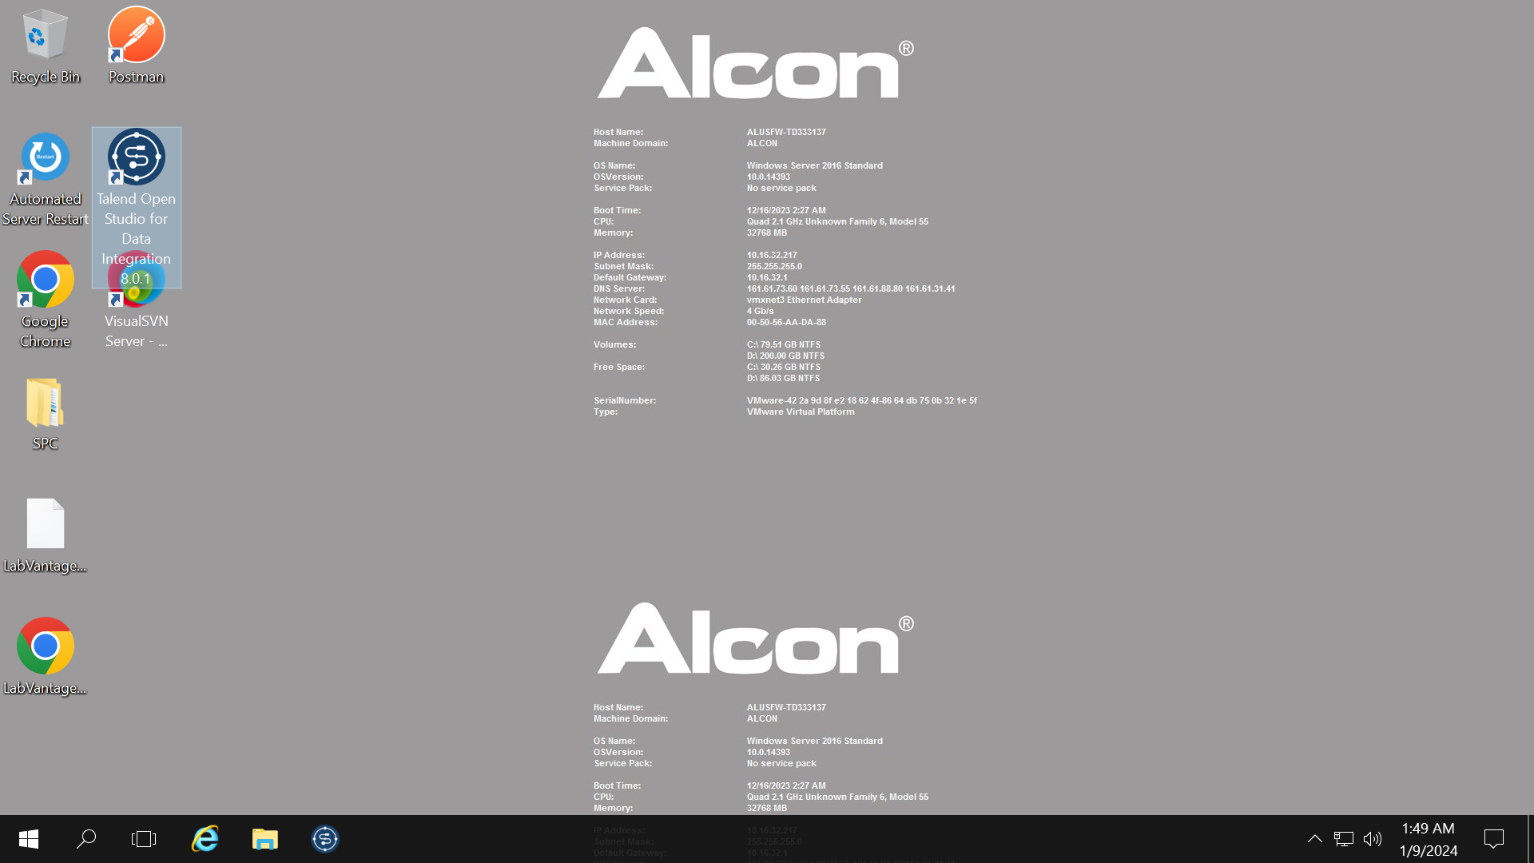

17. Double click on the Talend desktop icon to run the Talend Software. The below screen will appear then Select the existing project and click on Finish.

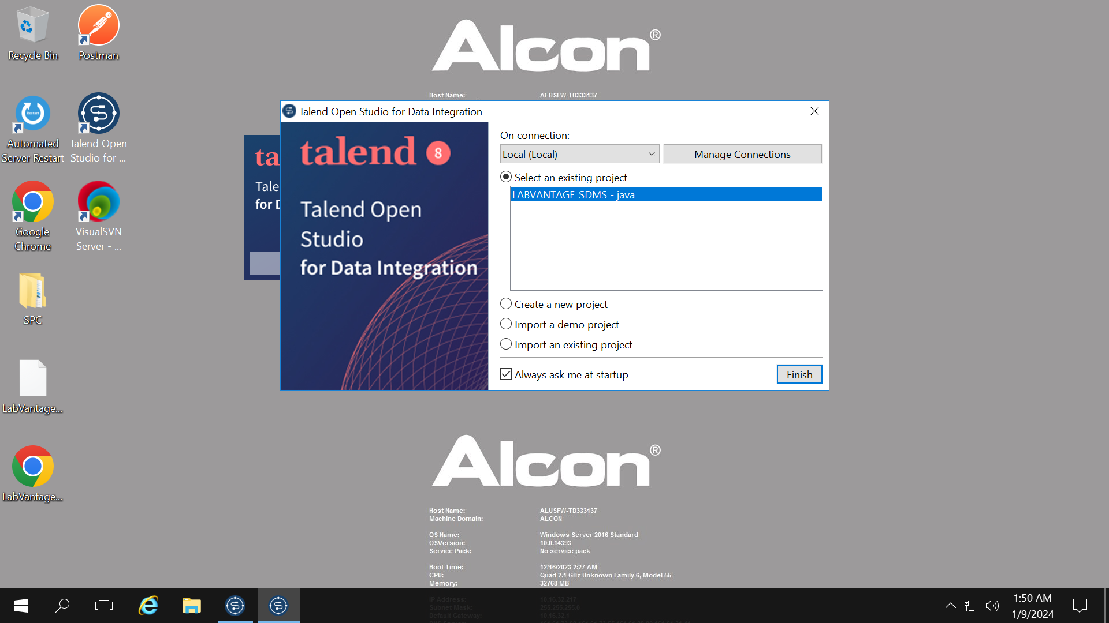

18. Now after clicking on Finish the Talend Editor Window will open as shown in the below image.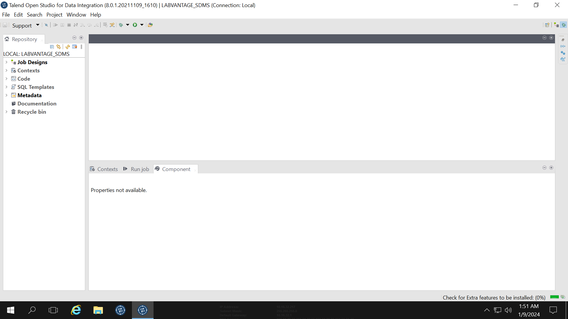

**Configuration of Talend Workspace**

If you have launched the Talend program, exit the program now.

Obtain the SDMSWorkspace.zip from Labvantage and extract it to your "C:\Talend\workspace\" folder (where C:\Talend\" is the Talend root installation). This creates a "C:\Talend\workspace\LABVANTAGE_SDMS\" folder. Take the "SDMSComponents.zip" and extract it into the "components" folder under the "LABVANTAGE_SDMS" workspace folder.

Prior to Labvantage 8.5, complex instruments were integrated with Labvantage using a component called LIMSCI. If you used this and you desire to migrate your drivers to Labvantage 8.5, you might want to optionally import additional components. If you require the LIMS CI migration components, then take "SDMSLIMSCIComponents.zip" and extract it into the same "C:\Talend\workspace\LABVANTAGE_SDMS\components" folder.

Now launch Talend and select switch projects/workspace.

Select the "Labvantage_SDMS" project and hit Finish. In some cases, you may have to use the "Import an existing project" option to import that workspace before you can select it on your list.

A successful import of the Labvantage workspace will give you seven example job designs in your repository (left panel) and eight Labvantage components (right panel). If you have optionally imported the LIMS CI components, six additional Labvantage components are available to you for a total of 14.

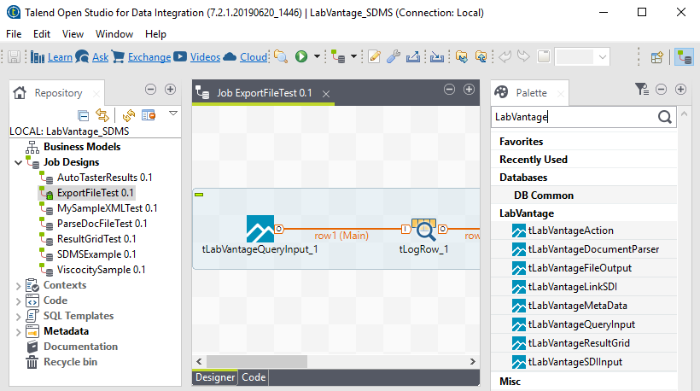

**Adding the sapphire.jar**

Using your Talend menus, navigate to Window > Preferences.

Within the Preferences dialog, expand **Java** then **Build Path** and select **User Libraries**

On the right, click the**New** button. Provide a name for this library. Do not tick "System library".

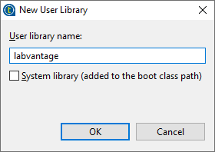

Click OK.

On the right, click the **Add External JARs...** button.

Browse your file system for the place where you have copied Labvantage's sapphire.jar

Once you are finished, your User Libraries should look like this:

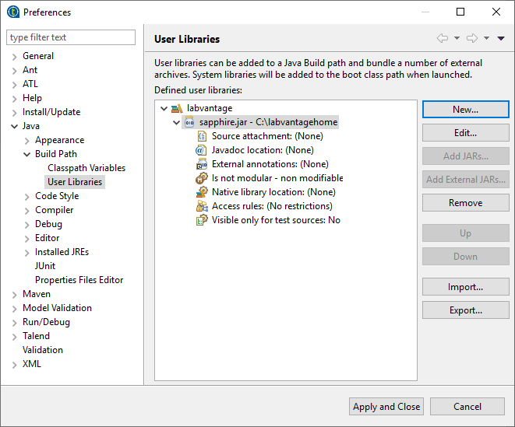

Click **Apply and Close.**